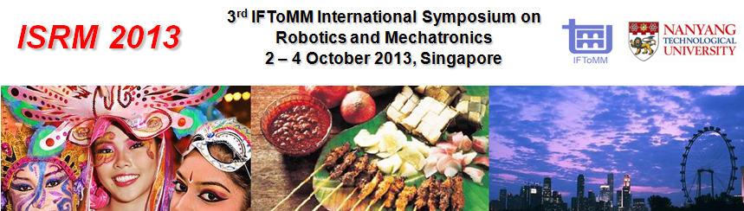
Industrial Forum Registration Form

To register, complete the form and email to ‘secretary@iftomm-isrm.org’. Please register by 13 September 2013.

PERSONAL PARTICULARS
Salutation | Mr  Ms  Mrs  Prof  Dr
First Name |  | Last Name
Name to appear on badge
Company Name
Company Address
City |  | Postal Code
Country |  | Email Address
Mobile Phone |  | Telephone
Special Dietary Requirement | None  Vegetarian 

PAPER INFORMATION
Are you an author of a submitted paper? | Yes  No
Paper Title
Paper Number
Are you the corresponding author of this paper? | Yes  No

FEES |  | AMOUNT
Select option | Description | Standard Rate
 | Industrial Forum | SGD 500

TOTAL FEE TO BE PAID: SGD

Registration and Payment Policies:
- Industrial Forum Registration Fee includes admission to technical sessions, coffee breaks and lunch.
- Please make payment via cheque payable to ‘Nanyang Technological University’ and send the cheque to the following address by 25 September 2013.
Mailing address:
NTU – Intelligent Systems Centre
(c/o School of MAE)
50 Nanyang Avenue, North Spine, N1-B3b-29
Singapore 639798
- For enquiries, please contact:
Noraidillah Bte Md. Ali
Secretary, ISRM2013
E-mail: secretary@iftomm-isrm.org
Telephone: +65 6790 6678

